HELP DESK TICKET
MANAGEMENT DASHBOARD
Revised Project Documentation
Microsoft Excel | IT Support / Help Desk Operations

1. Project Overview
This project is an Excel-based help desk ticket register and dashboard. It records support requests, captures the troubleshooting performed, tracks each ticket's status and resolution, and summarizes the workload in a visual dashboard.

2. Project Objectives
- Record and organize reported IT support issues.
- Capture ticket priority, assigned technician, troubleshooting steps, and resolution details.
- Track whether each ticket is Open, In Progress, or Resolved.
- Summarize ticket volumes using formula-driven dashboard metrics.
- Visualize ticket status counts with a column chart.

3. Workbook Structure
Worksheet | What it contains
Sheet1 – Ticket Register | The source data for individual help desk tickets, including issue details, priority, technician, status, troubleshooting, resolution, and dates.
Dashboard | Summary metrics, a ticket-status count table, and a chart showing ticket distribution by status.

4. Ticket Register: Fields Captured
Field | Purpose
Ticket ID | Unique reference assigned to each support request.
Date Reported | Date the issue was reported.
User/Department | Department or user reporting the issue.
Issue Description | Short description of the technical problem.
Priority | Priority level assigned to the issue.
Assigned Technician | Technician responsible for handling the ticket.
Status | Current ticket stage: Resolved, In Progress, or Open.
Troubleshooting Steps | Actions taken to investigate or troubleshoot the issue.
Resolution | Outcome or fix applied, where available.
Date Resolved | Date the issue was resolved, where applicable.

5. Sample Tickets Entered
The workbook currently contains three sample tickets. The table below summarizes the records without reproducing unnecessary troubleshooting detail.
Ticket ID | Department | Issue | Priority | Status
HD-001 | Accounts Department | Unable to connect to Wi-Fi | High | Resolved
HD-002 | Human Resources | Printer not printing documents | Medium | In Progress
HD-003 | Administration | Computer running slowly | Low | Open

6. Dashboard Results
Based on the three records currently entered, the dashboard summary is:
Metric | Current count
Total Tickets | 3
Resolved Tickets | 1
In Progress | 1
Open Tickets | 1
The “Tickets by Status” column chart displays one Resolved ticket, one In Progress ticket, and one Open ticket. The counts add up to the total of three tickets.

7. Excel Formulas and Dashboard Logic
The dashboard uses COUNTIF and COUNTA formulas to calculate the figures from the Ticket Register. The current workbook includes these formula patterns:
- Total tickets: =COUNTA(Sheet1!A2:A1000)
- Resolved tickets: =COUNTIF(Sheet1!G:G,"Resolved")
- In-progress tickets: =COUNTIF(Sheet1!G:G,"In Progress")
- Open tickets: =COUNTIF(Sheet1!G2:G1000,"*open*")
- Status table: COUNTIF formulas count the number of records matching each status.
These formulas allow the summary to recalculate as records are added or their statuses change, within the ranges covered by the formulas. The chart is based on the status summary table.

8. Features Completed
- Created a structured help desk ticket register.
- Recorded ticket IDs, reporting dates, departments, issue descriptions, and priorities.
- Captured assigned technician, status, troubleshooting actions, resolution, and resolution date.
- Built dashboard metrics using Excel counting formulas.
- Created a ticket-status summary table.
- Inserted and formatted a column chart with a chart title and data labels.
- Saved the workbook for future updates.

9. Skills Demonstrated
- Excel data entry and structured worksheet organization.
- Using COUNTA and COUNTIF functions to summarize records.
- Tracking IT incidents and documenting troubleshooting actions.
- Categorizing support requests by priority and status.
- Creating charts and presenting operational information visually.
- Checking dashboard totals against the underlying ticket register.

10. How to Use and Update the Workbook
- Open Sheet1 and enter each new support request on a new row, keeping the same column order.
- Assign a unique Ticket ID and enter the report date, department, issue, and priority.
- Record the assigned technician and update the status as work progresses.
- Document troubleshooting steps and enter the resolution and date resolved when the issue is fixed.
- Open Dashboard and confirm the summary figures and chart reflect the updated register.
- If a new status category is introduced, add it to the dashboard summary table and update the chart source range.

11. Scope and Limitations
This is a small, manually maintained Excel demonstration project. It records and summarizes tickets but is not a full help desk application. The workbook does not currently demonstrate automatic ticket assignment, email alerts, user logins, SLA monitoring, a database backend, or integration with a commercial ticketing platform.

12. Possible Future Enhancements
- Add more realistic sample tickets across different issue categories and priority levels.
- Add filters or Excel table functionality to make the register easier to search.
- Track response time, resolution time, and overdue tickets.
- Add charts for ticket priority, issue category, or technician workload.
- Use conditional formatting to highlight high-priority or overdue tickets.
- Protect formula cells to reduce accidental changes.

13. Portfolio Project Description
Developed an Excel-based Help Desk Ticket Management Dashboard to record IT support incidents and monitor ticket status. Created a structured ticket register containing issue details, priority, assigned technician, troubleshooting actions, and resolution information. Used COUNTA and COUNTIF formulas to calculate ticket totals and status counts, then visualized the results with a column chart.

14. CV / LinkedIn Project Entry
Help Desk Ticket Management Dashboard | Microsoft Excel
Created an Excel-based ticket register and dashboard to document IT support incidents, track priority and resolution status, and summarize ticket volumes. Applied COUNTA and COUNTIF formulas and built a column chart to visualize resolved, in-progress, and open tickets.

15. Portfolio Evidence Checklist
- The completed Excel workbook.
- A screenshot of the Ticket Register showing the sample records.
- A screenshot of the Dashboard showing the summary metrics and chart.
- This project documentation.

Small workbook check
In the uploaded workbook, the Dashboard label in cell A4 is currently spelled “Resoled Tickets”. Correct it to “Resolved Tickets” for a polished final version. Also ensure the status formula and chart continue to count the Open ticket correctly after future edits.
Accuracy note: This documentation is based on the uploaded workbook and the three ticket records currently present. It describes the existing Excel features and does not claim unimplemented automation or integrations.

Appendix A: Workbook Screenshots
The following photographs provide visual evidence of the two worksheets in the completed Excel project.

A1. Sheet1 – Help Desk Ticket Register
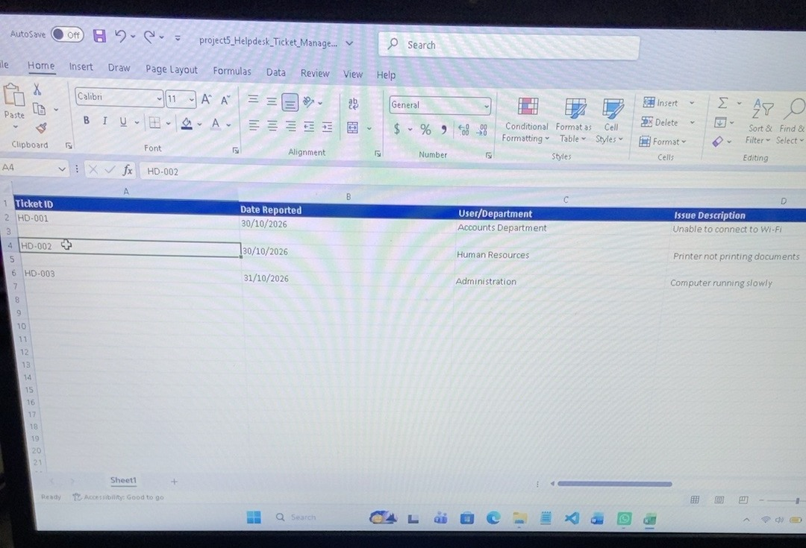
The register contains three sample support tickets, with ticket IDs, dates reported, departments, and issue descriptions visible. The remaining fields continue across the worksheet to the right.

A2. Dashboard – Ticket Summary and Chart
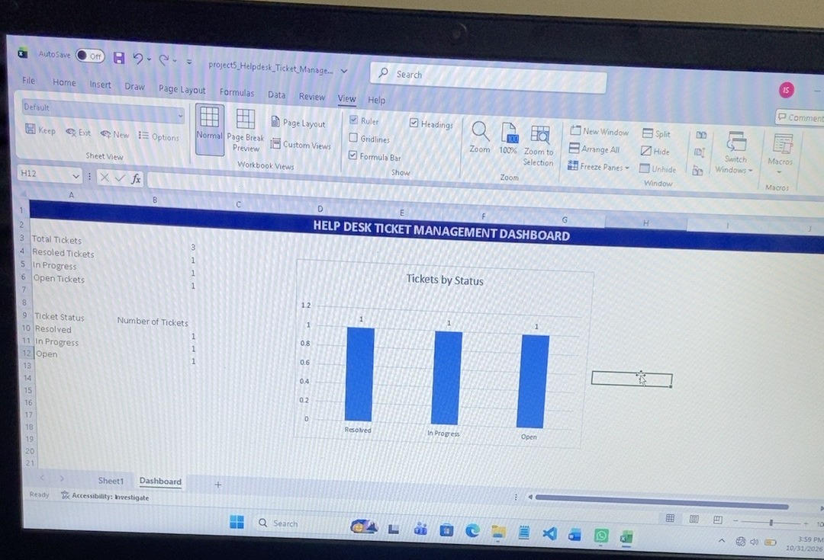
The dashboard displays the total ticket count and the breakdown of Resolved, In Progress, and Open tickets, together with a column chart titled “Tickets by Status”.

